Content of report

Introduction ……………………………………………………...3

How to system working…………………………………………4,5

Requirement in the system………………………………………6-12

Screenshot………………………………………………………...13

Table 1 username and password…………………………….........6

Table 2,3 requirments&Vaalidation……………………………...7,8

Figure 1 ClassDiagram…………………………………………...13

Figure2 Database (username, password) ……………………........3

Figure 3 flow diagram……………………………………………...4

Figure4 How to run the system ……………………………………5

Figure 5 Class diagram………………………………………........12

Figure 6 ER diagram ……………………………..........................15

Figure 7 Login view………………………………………………16

Figure 8 Login successful………………………………………...17

Figure 9 open dashboard …………………………………….........17

Figure 10 Manufacture view……………………………………...18

Figure 11 Model view…………………………………………….18

Figure 12 Add car view …………………………………………..19

Figure 13 Delete car view…………………………………………19

Figure 14 Search car view…………………………………………20

Figure 15 Upgrade view…………………………...........................20

Figure 16 view sold car view………………………......................21

Figure 17 Seller login successful…………………………………21

Figure 18 Select car and add new upgrade……………………….22

Figure 19 Add new Upgrade view……………………………….22

Figure 20 Sale view………………………………………………23

Figure 21 Manufacture database (not hard code) ………………..23

Figure 22 Model database (not hard code) ………………………24

Figure 23 Upgrade database (not hard code) …………………….24

Figure 24 Sale database (not hard code)………………………….25

Introduction

The cars sale system divided into three-part View (UI), Logic, Model. This system follows OOP concept in python

Model: It includes all the data and its related logic

View: Present data to the user or handles user interaction

Controller: An interface between Model and View components

.

* The system gives combo-box, button facilities to select the values for entry. So do not try to hard code. Example If you want to Delete car then without sale cars are show in the combo box in the system so select one of that. Don’t write the car Regnum in the entry field
* Directly insert the Username and Password in the database

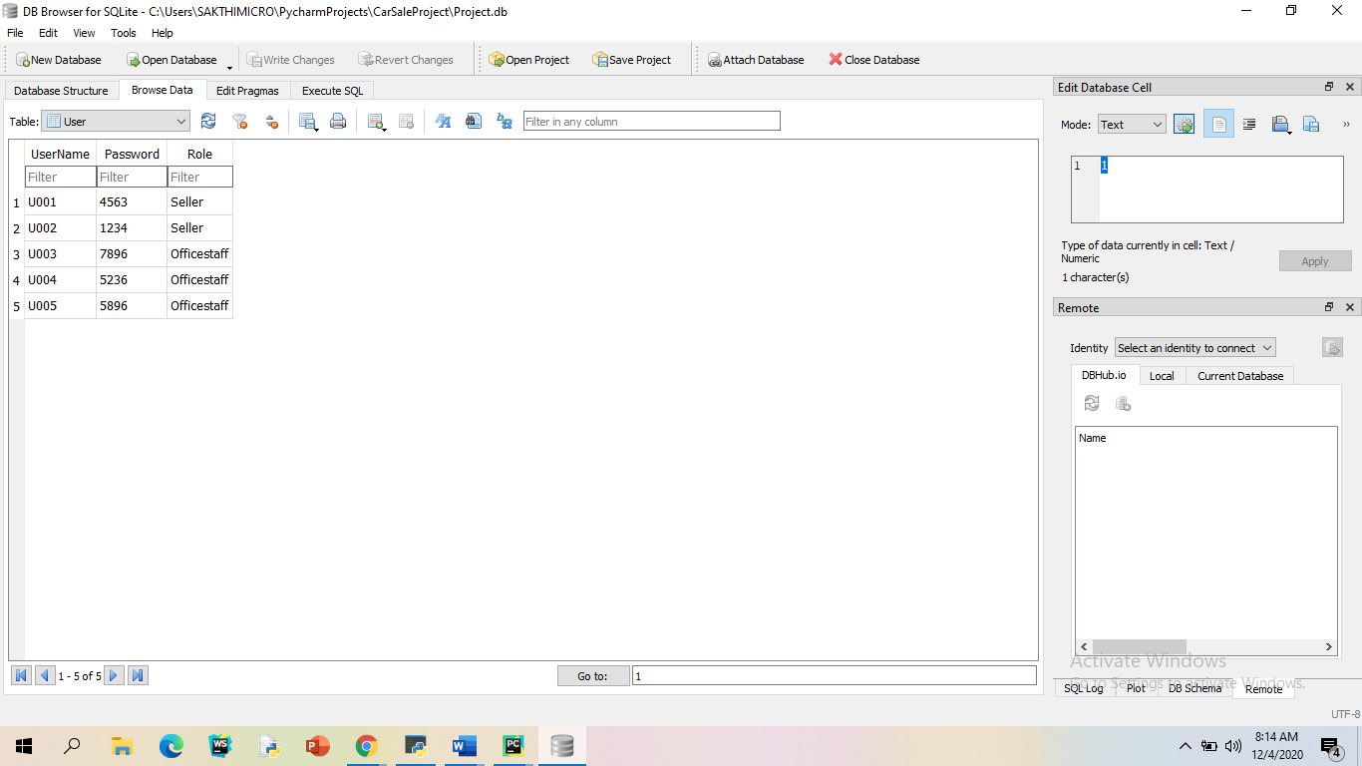

*Figure2*

*database username and password*

How to run the system

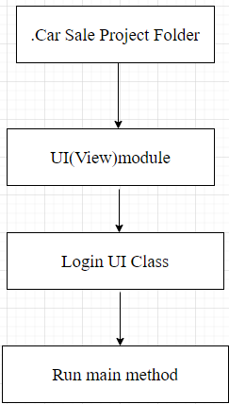

*flow diagram(figure 3)*

How to run the system in python

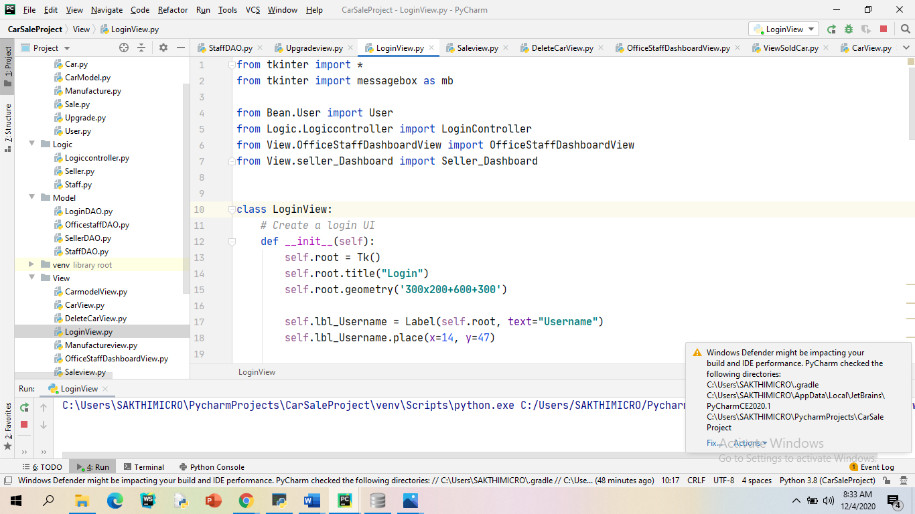

*how the system work*

**Requirement in the System**

|  |  |  |  |  |
| --- | --- | --- | --- | --- |
| Module | Requirements | Validation | **pass** | **fail** |
| Authentication | login the system by user (Office staff, Seller). |  |  |  |
|  | logout the system by user (Office-staff / Seller). |  |  |  |
|  |  | username or password are incorrect. |  |  |
| Manufacture | Add new manufacture |  |  |  |
|  |  | If the manufacture id already exists in the database. |  |  |
|  |  | If the manufacture name already exists in the database |  |  |
|  |  | If the manufacture id or manufacture name entry fields are blank. |  |  |
| Car Model | Add new model |  |  |  |
|  |  | If the model id already exists in the database |  |  |
|  |  | If the model name already exists in the database. |  |  |
|  |  | If the manufacture doesn’t exist in the database |  |  |
|  |  | If the any of fields are blank. |  |  |

|  |  |  |  |  |
| --- | --- | --- | --- | --- |
| Car | Add new car |  | Yes |  |
|  |  | If the car registration number already exists in the database |  |  |
|  |  | If the model doesn’t exist in the database |  |  |
|  |  | If the any of fields are blank |  |  |
|  | Add new upgrade or upgrades |  |  |  |
|  |  | If the car registration number doesn’t exist in the database. |  |  |
|  |  | If the selected upgrade or upgrades already exists in the selected car |  |  |
|  |  | If at least one upgrade doesn’t select for selected car. |  |  |
|  | Delete Car |  |  |  |
|  |  | If the car registration number doesn’t exist in the database. |  |  |
|  |  | If the car already sold. |  |  |
|  |  | If the car registration number doesn’t select. |  |  |
|  | Search car |  |  |  |
|  |  | If the model or manufacture doesn’t exist in database |  |  |

|  |  |  |  |  |
| --- | --- | --- | --- | --- |
|  |  | If model or manufacture doesn’t select. |  |  |
|  | View sold car |  |  |  |
|  |  | If the sold car doesn’t select. |  |  |
| Sale | Select car for sale |  |  |  |
|  |  | If the car doesn’t exist in database. |  |  |
|  |  | If the car already sold. |  |  |
|  | Select sale car details and upgrades |  |  |  |
|  |  | If the car doesn’t exist in database.  If the car doesn’t select |  |  |
|  |  | If the car doesn’t select |  |  |
|  | Sale car |  |  |  |
|  |  | If the currency doesn’t select |  |  |
|  |  |  |  |  |

**The requirements through your system**

1.

Login

• The database has username and password for login the user (Office staff and seller). If the username or password doesn’t match, it’ll not allow to access the system.

• If the username matches for seller, it’ll open the seller dashboard

• If the username matches for office-staff, it’ll open the office-staff dashboard

2.

Add manufacture

• The office-staff can be added a new manufacture under the certain validation mention above.

• Manufacture ID and manufacture name must be unique otherwise it doesn’t allow to add new manufacture by office-staff

* If the manufacture id or manufacture name are not unique then system message will be display

3.

Add model

• The office-staff can be added a new model under the certain validation mention above.

• The model ID and model name must be unique. If the user enters model ID and model name that are already exists, the system will be produced the warning message to user. Otherwise, it will be produced the success message.

• The price must be given for the new model

The system has a combo-box to select the manufactures that are already existed. The feature is very useful for add the available manufacture for particular model.

4. Add car

• The office-staff can be added a new car under the certain validation mention above.

• The color and number of doors must be given for particular car. otherwise, the system doesn’t allow to user add a car.

• The user can be select the available model for particular car in combo-box. Don’t need to hard code it.

5.

Add upgrade

• Office staff or seller can be added one or more additional components (upgrade) for selected car.

• User can be selected available car in database using combo-box

* User can be added upgrades for selected car by combo box. Upgrades can be one or more.
* The user wants to add new upgrade for car. They must be selected at least one upgrade.
* If the selected upgrades already exist for the particular car, the system will not allow to store the upgrades information in databases.

6.

Delete car

• Office staffs can be selected car in combo-box for delete.

• The cars that were not sold, because if they sold, it would be in sales table. If the user deletes the car, the sales information will be lost.

7.

Search car •

The office staff can be searched the model or/and manufacturer.

• The search results will be displayed car information under the selected model and manufacturer.

• If the user only selects the model name or manufacture name, the result will be under the particular model or manufacture.

• If the user selects model name and different manufacture name that is not represent the selected model, the result will be selected model name and manufacture name.

• User must be selected at least once model or manufacturer, otherwise the system produced the error message.

8.

View sold car

• The office staff can be selected sold cars in combo-box to view sold cars with their upgrades and final price.

• Due to that reason, in delete state the sold cars registration numbers are not deleted in car table.

9.

Sale car

The seller can be selected available cars that are not already sold in combo box.

• They can see the selected car details with upgrades to sell.

• If the customer wants to more upgrades, the seller can be added those upgrades.

• After select the sale car button to sell the selected car. The customer wants to pay for the car in different currencies the currency, the system also able to give the facility to select the currency type in combo-box, but must be select payment currency type. Otherwise, the system not allowed to sell the car

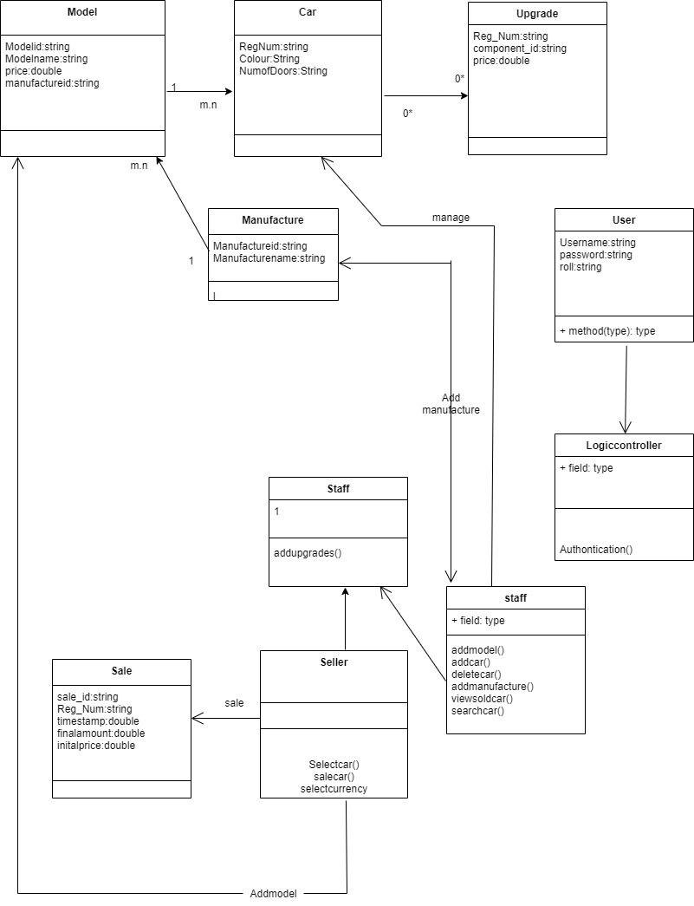

*Class diagram figure5*

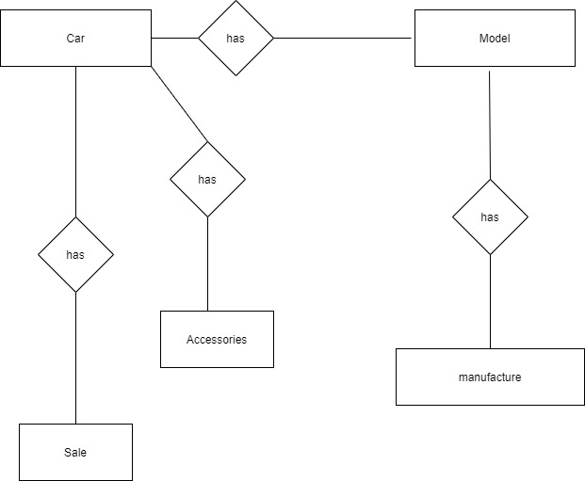

*ER diagram(figure 6)*

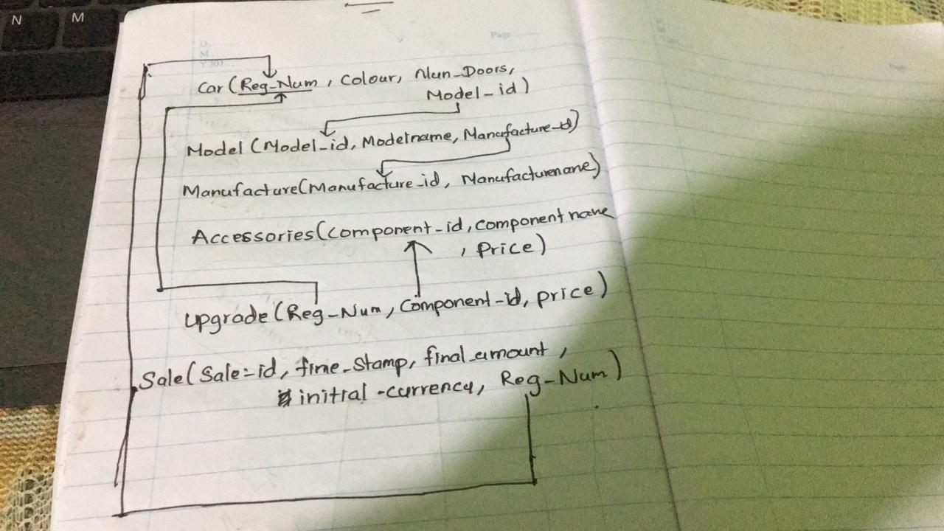

System Screenshots

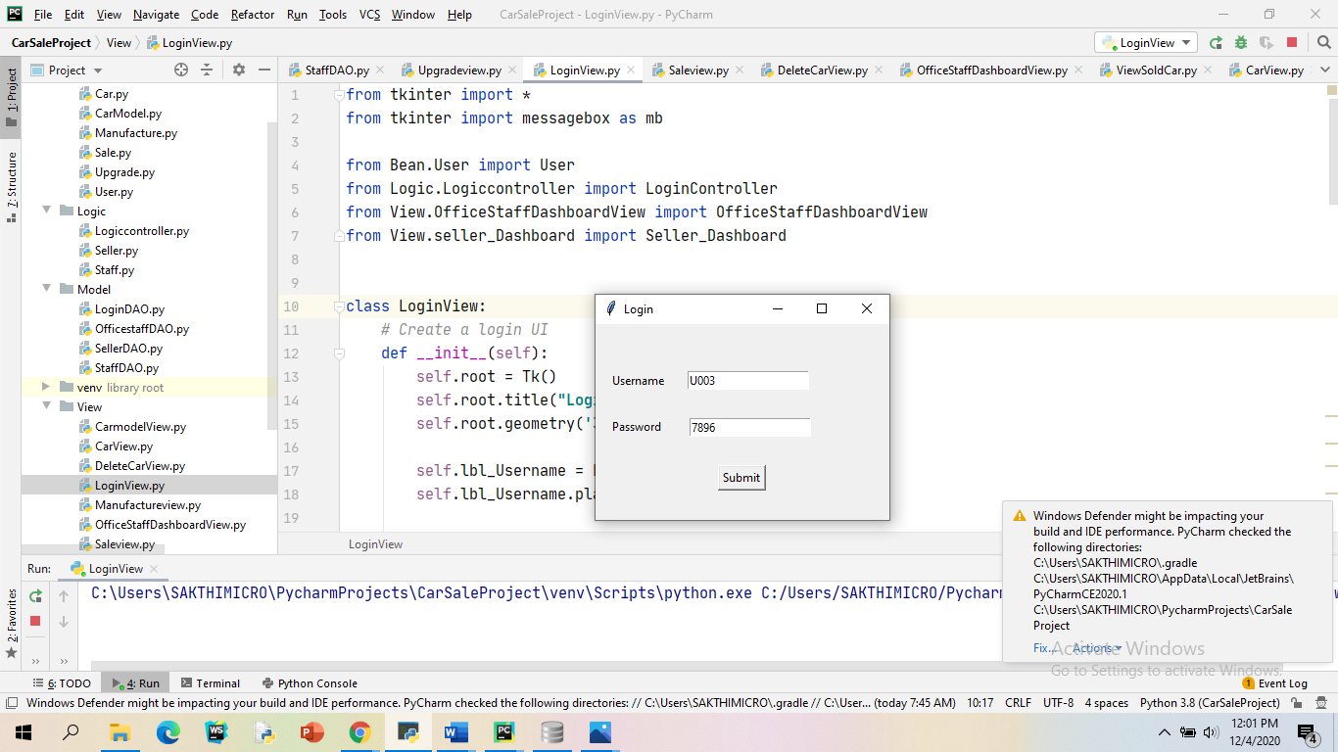

*Figure 7(username and password--login)*

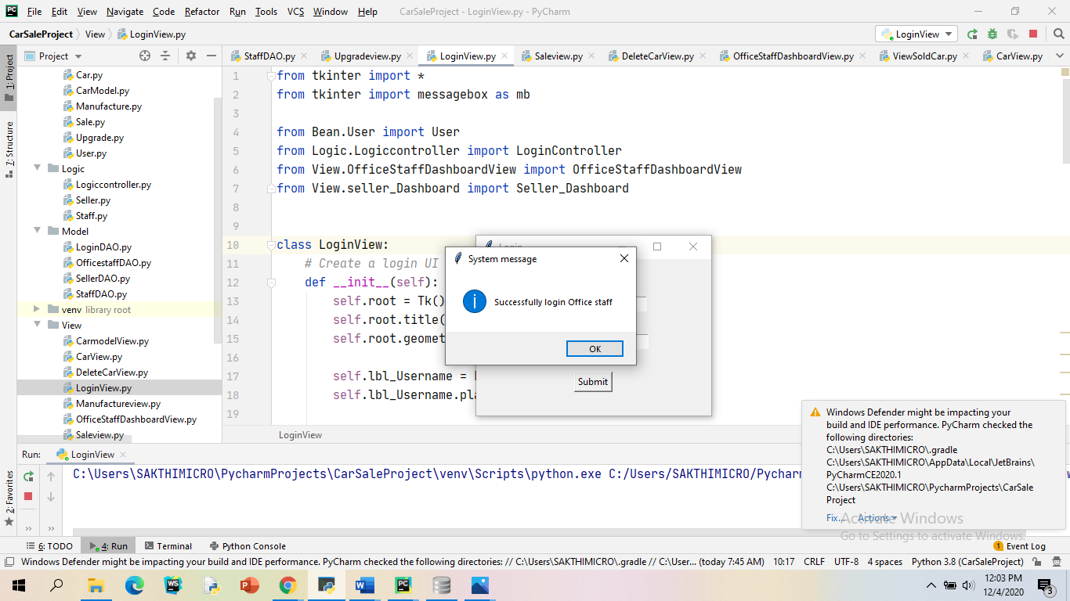

*Figure 8(login successful)*

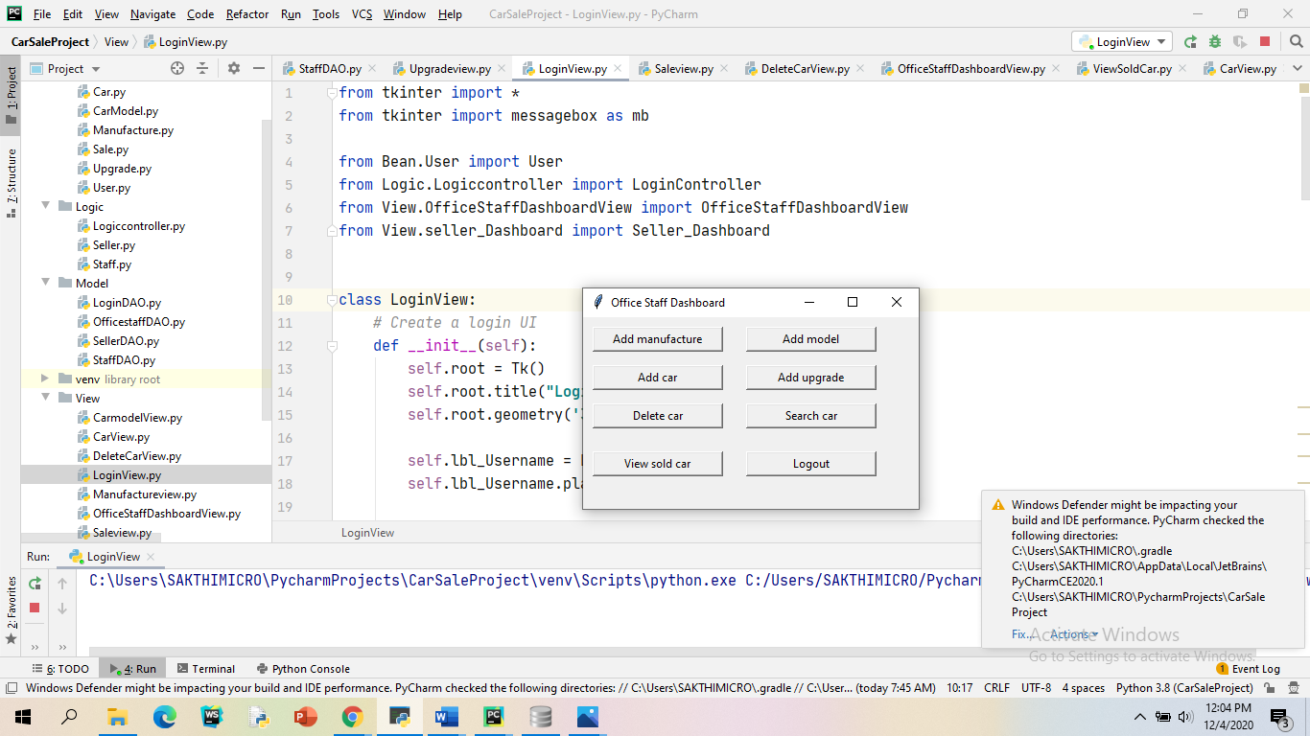

*Figure 9(open office staff dashboard)*

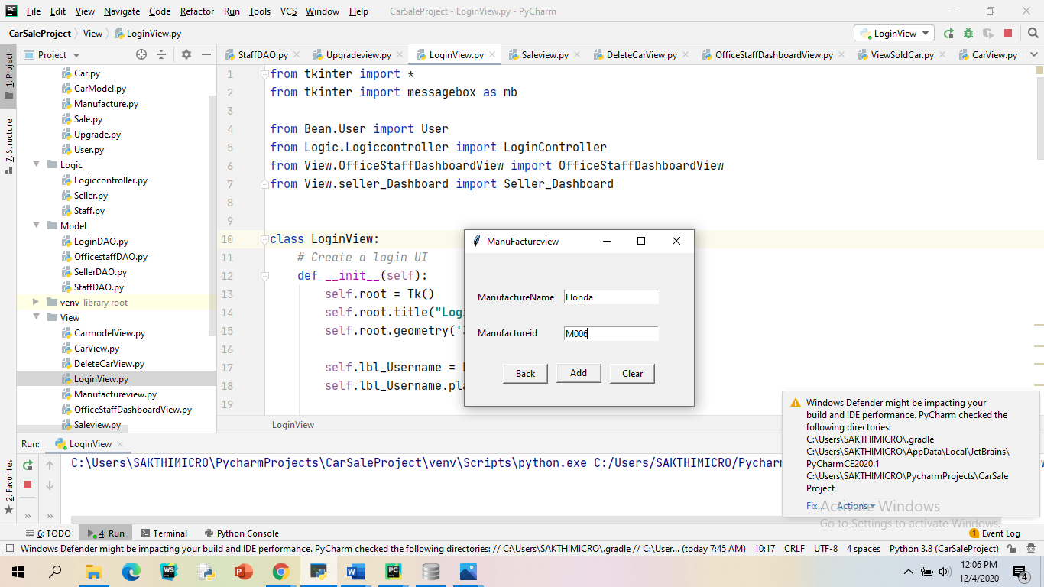

*Figure 10(Manufacture view)*

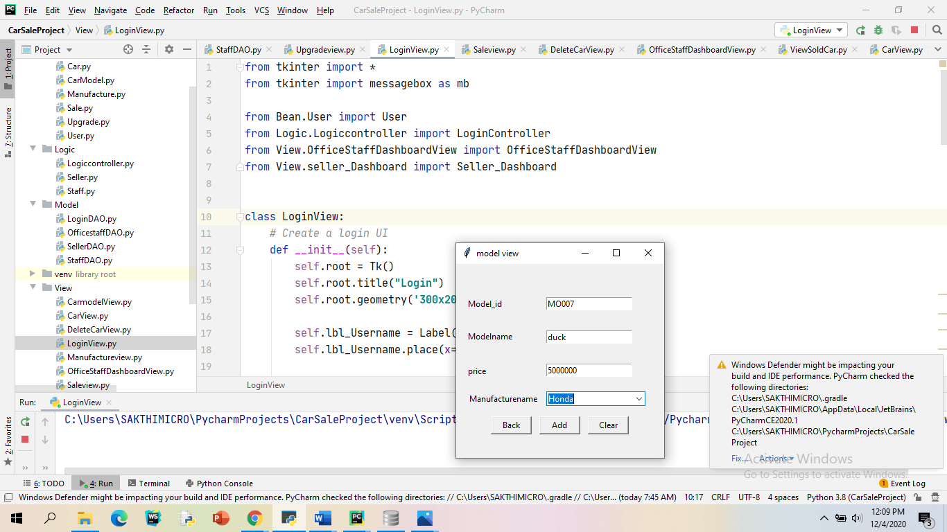

*Figure 11(model view)*

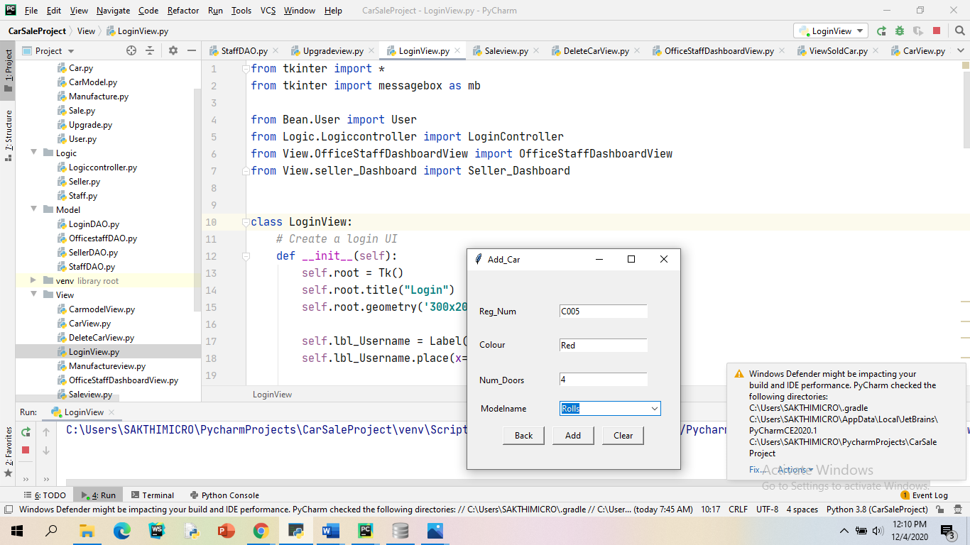

*Figure 12(Add car view)*

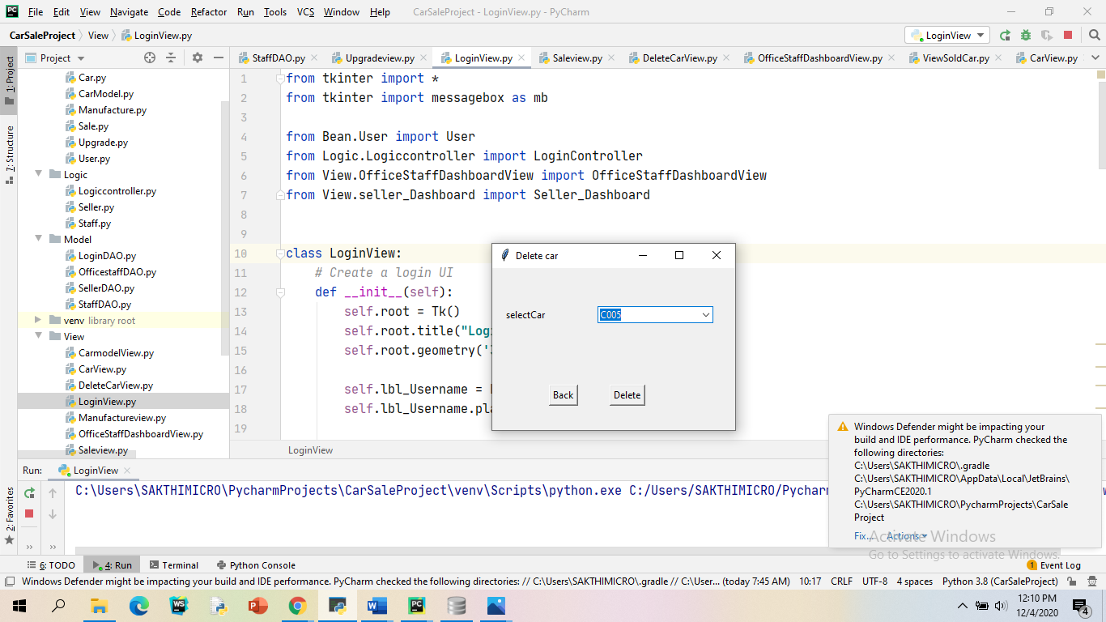

*Figure 13(delete car)*

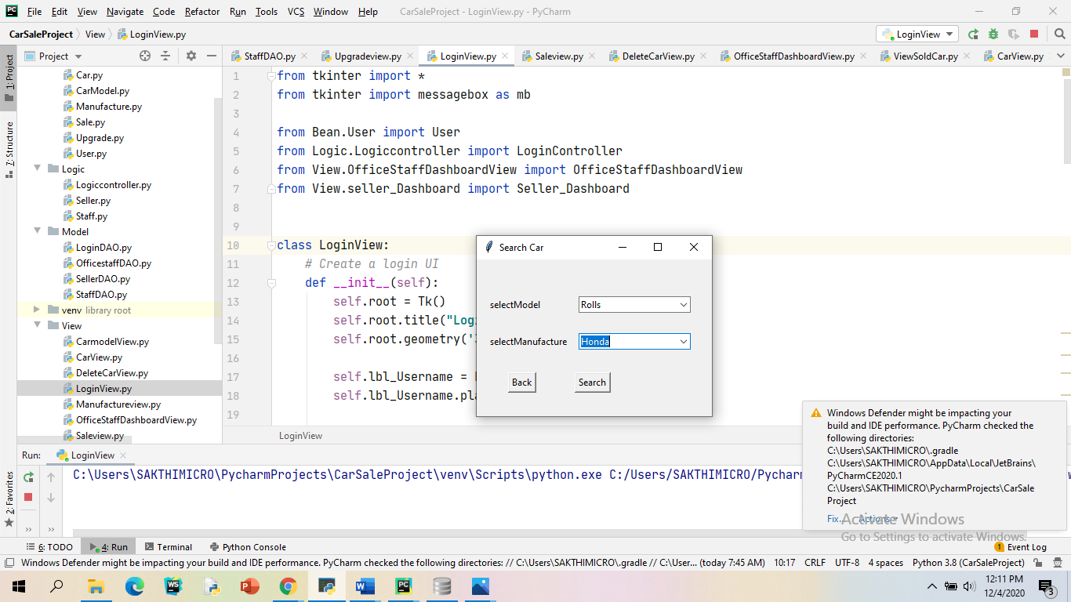

*Figure 14(search car)*

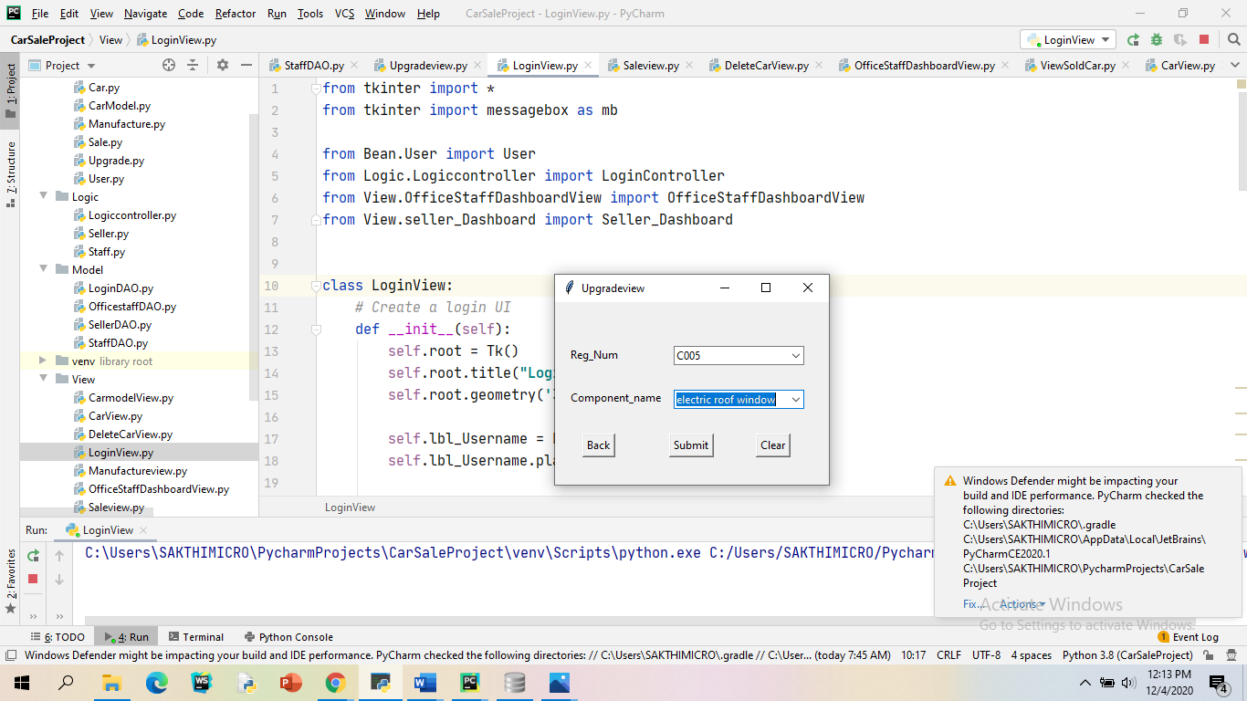

*Figure 15(Upgrade view)*

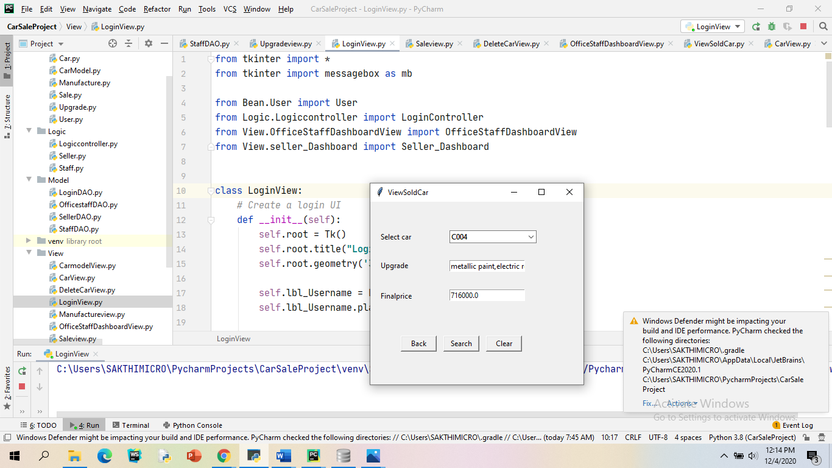

*Figure 16(view sold car)*

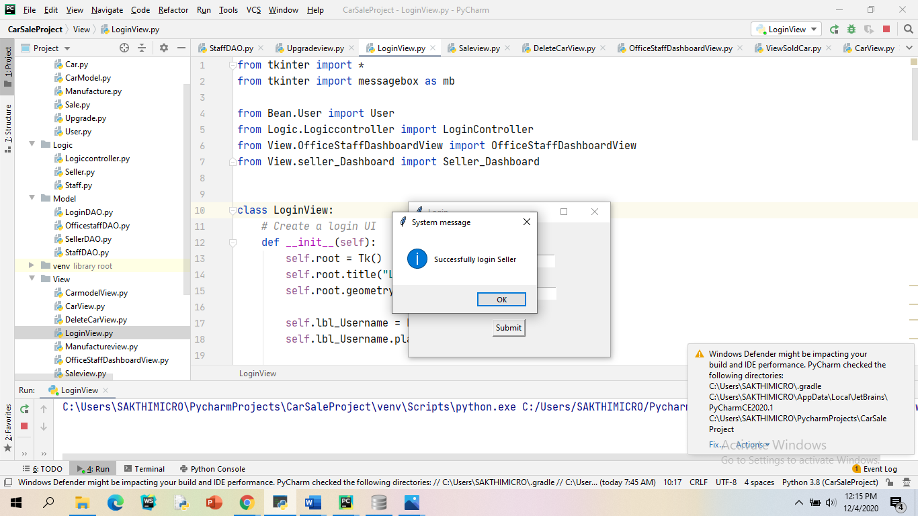

*Figure 17(Seller login Successful)*

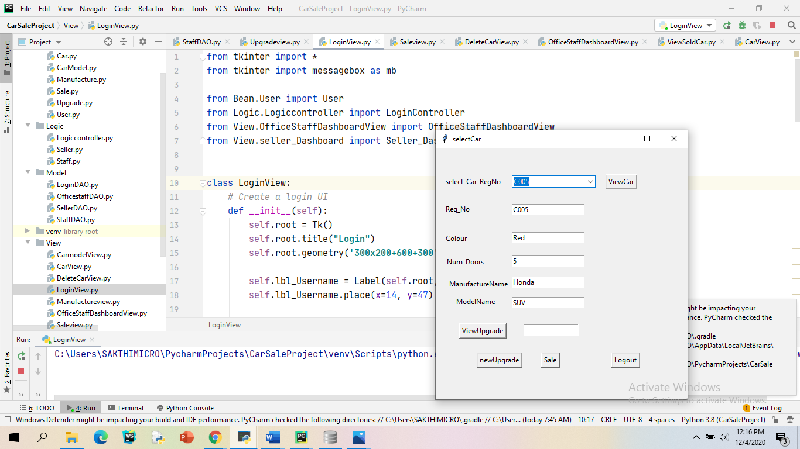

*Figure18(Select car and add new upgrades*)

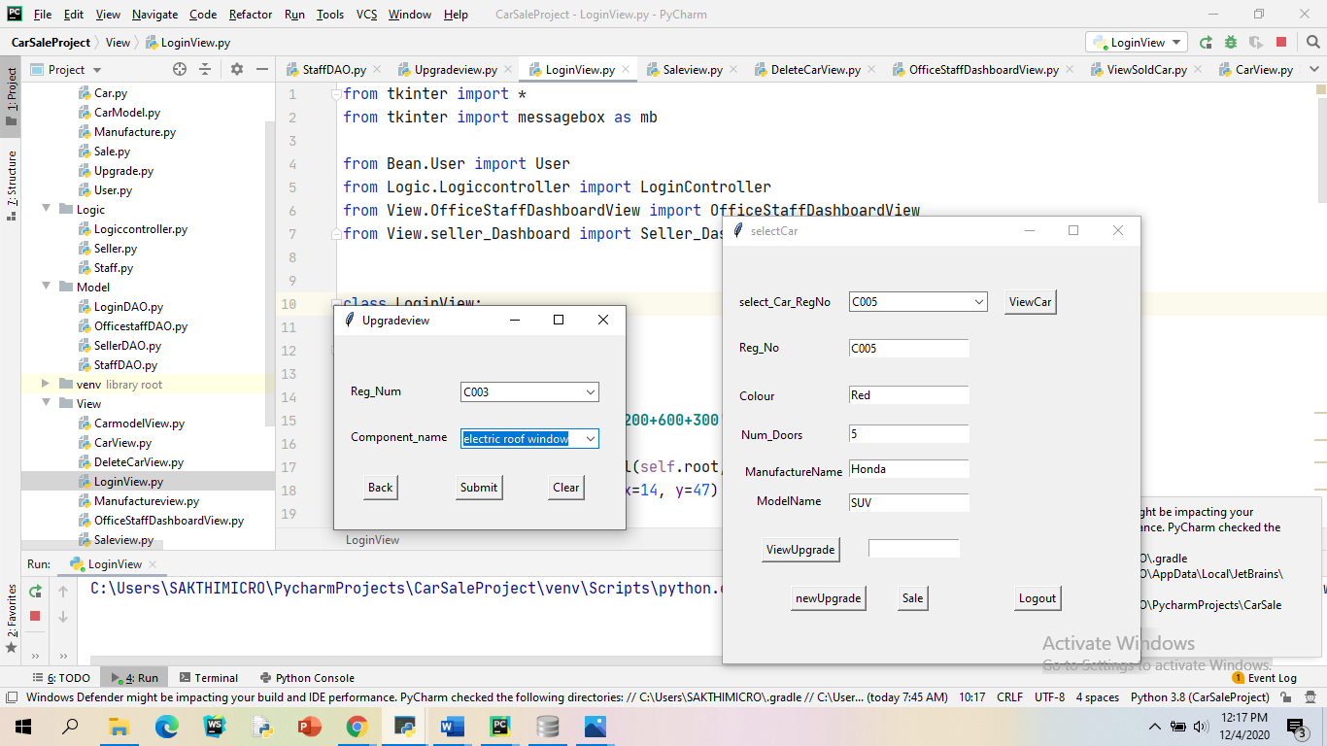

*Figure 19(Add new upgrade view)*

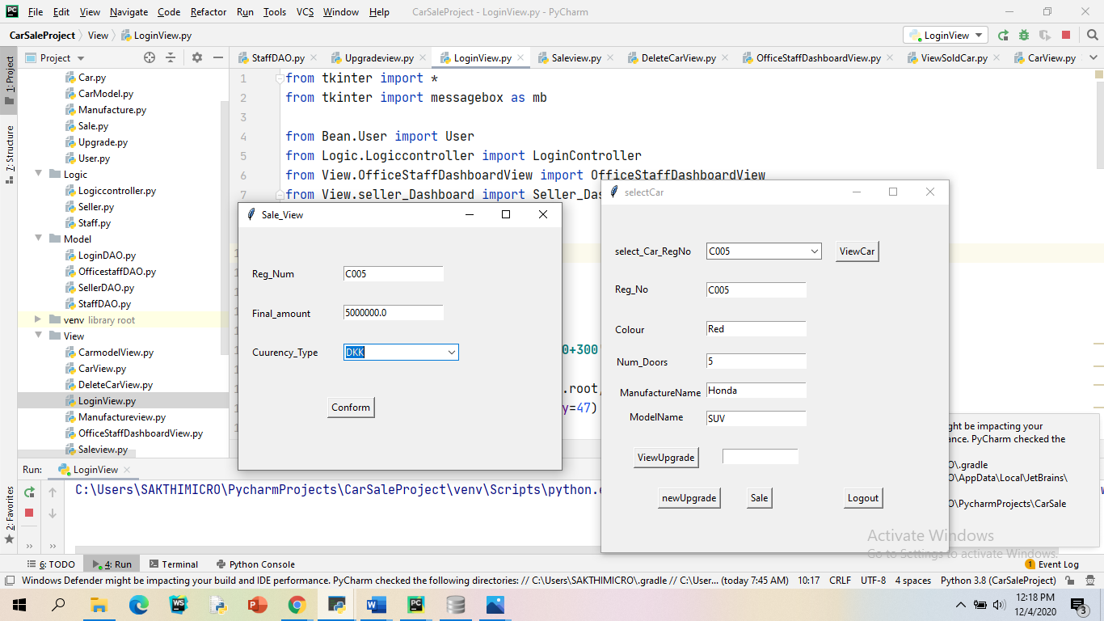

Figure 20(Sale view)

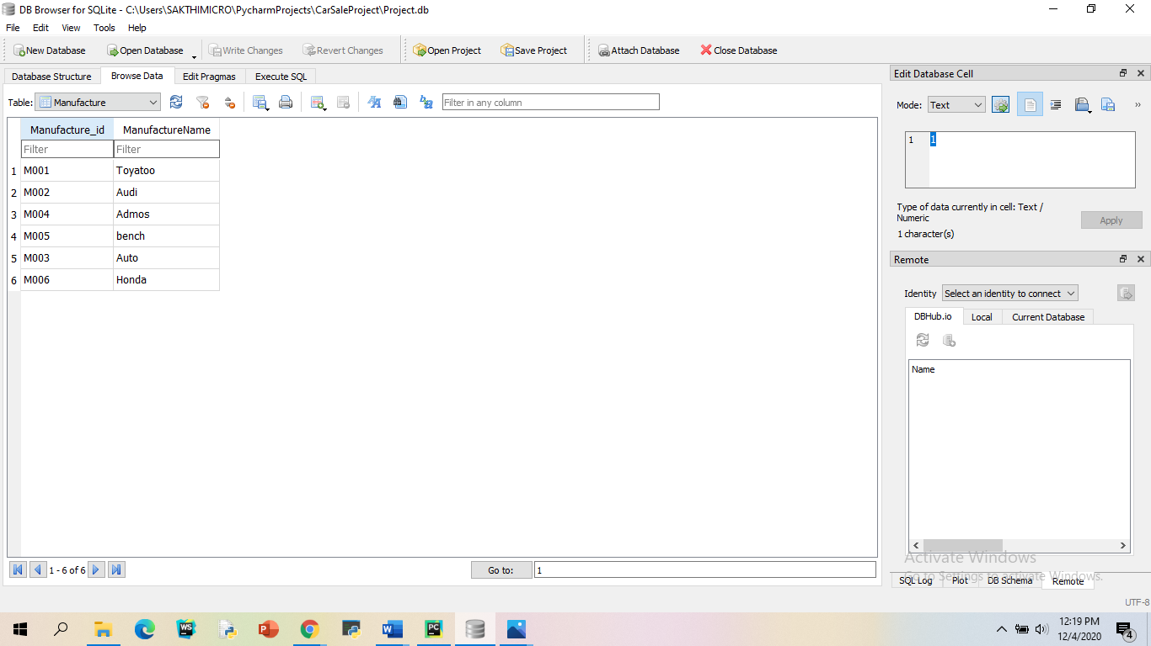

*Figure21(Manufacture database)*

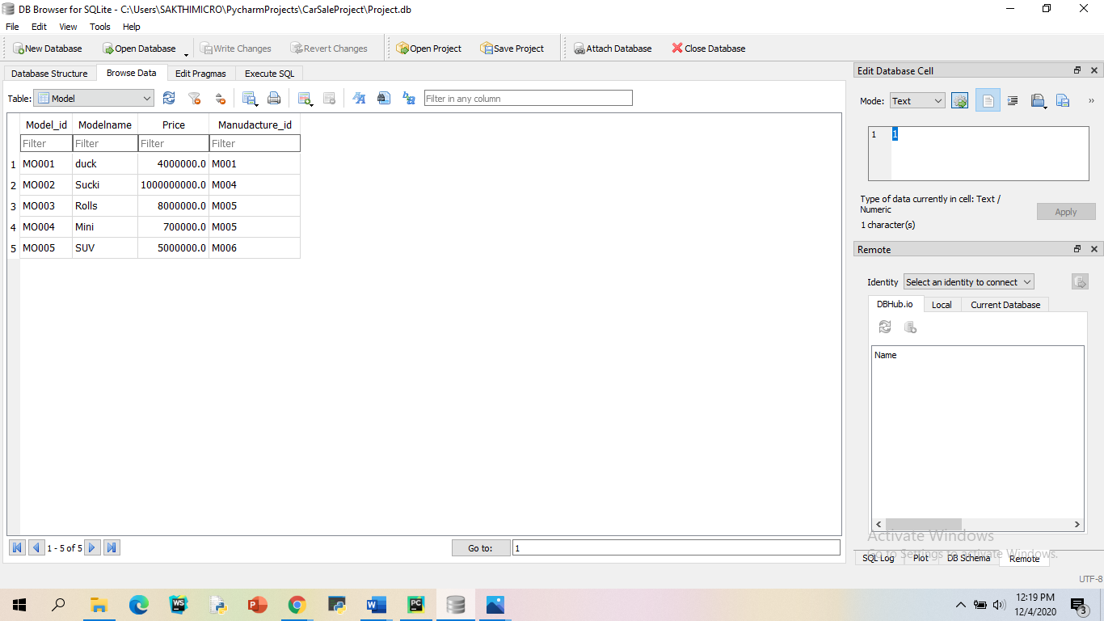

*Figure22 (model database)*

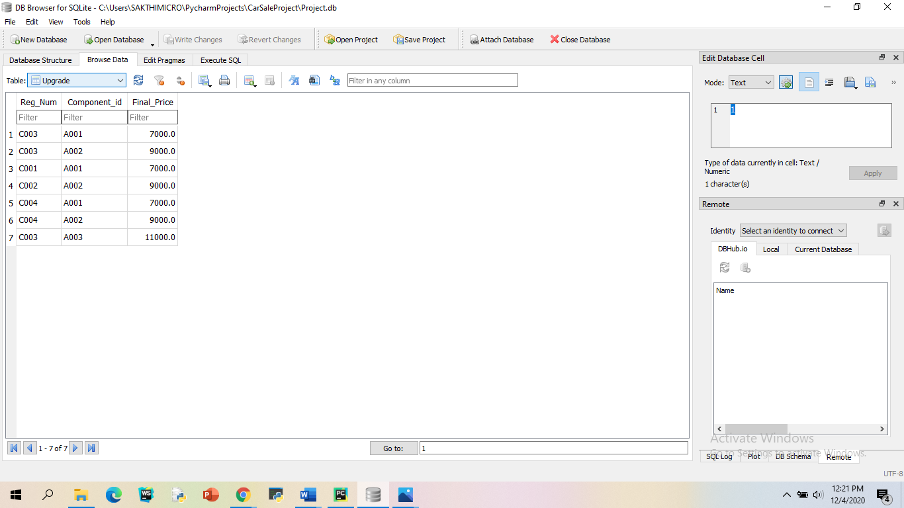

*Figure23 (upgrade database)*

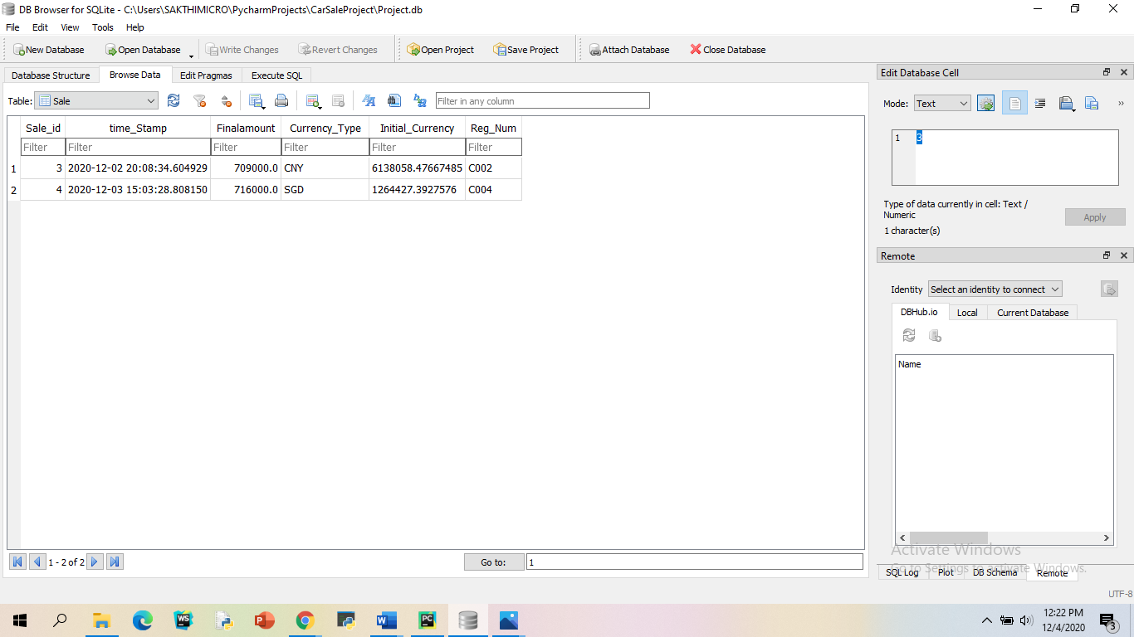

*Figure24(Sale database)*